Terminal 1 :

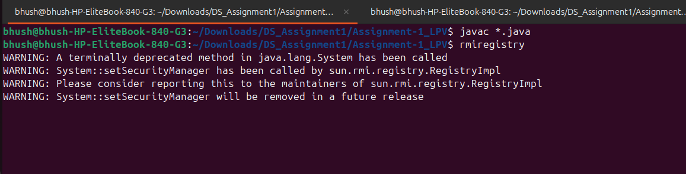
javac *.java rmiregistry

Terminal 2 :

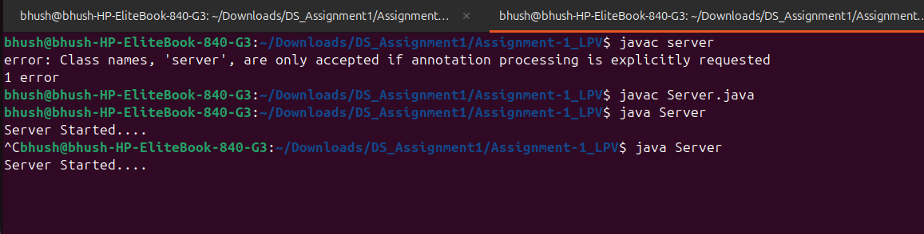
javac Server.java java Server

Terminal 3 :
java Client
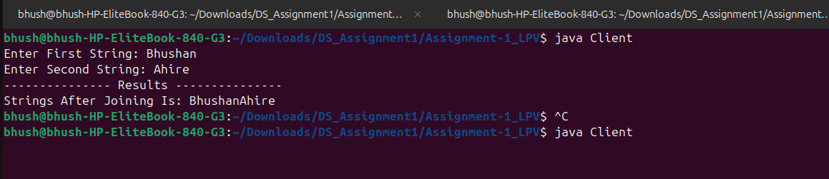
Enter 1st String : abc Enter 2nd String : xyz then Output

installation :
sudo apt update
sudo apt install mpich

Terminal 1 :
mpicc -o sum1_mpi sum1_mpi.c mpirun -np 4 ./sum1_mpi
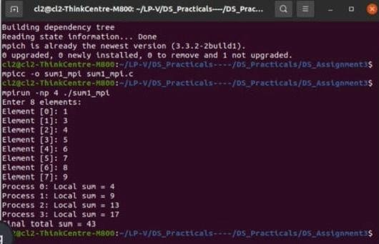

Terminal 2 :-
Sudo apt install gcc
gcc -fopenmp -o sum1_omp sum_1_omp.c
./sum1_omp
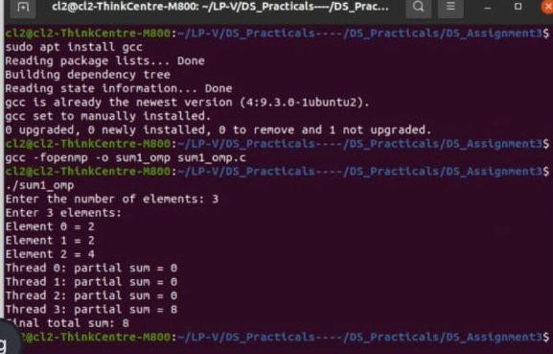

installation :
sudo apt install python-is-python3

Terminal 1 :
python3 server.py
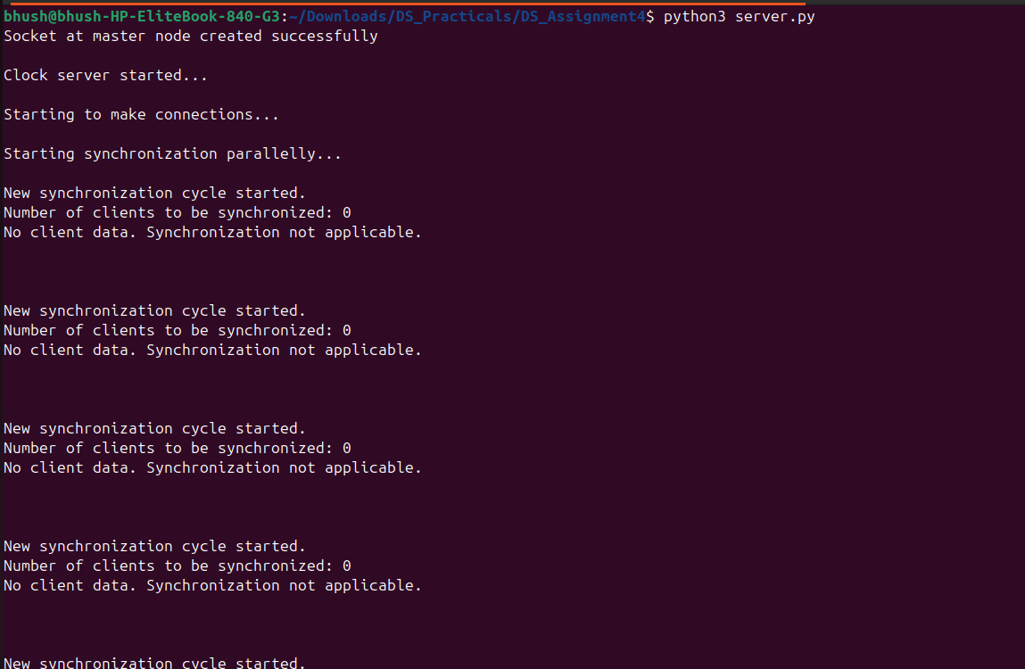

Terminal 2 :
python3 client.py
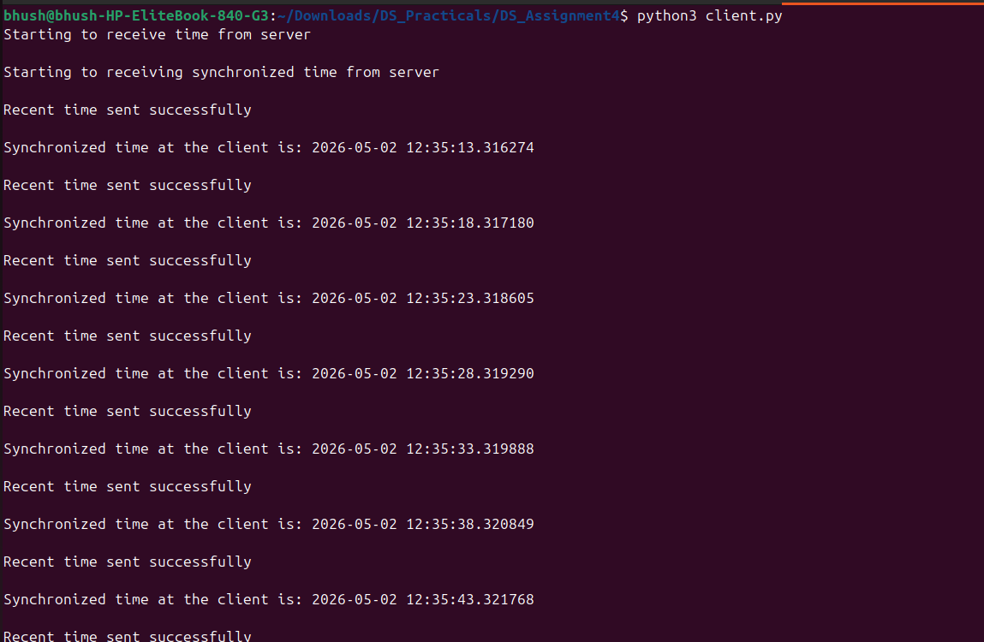

Practical No:5

Terminal 1:

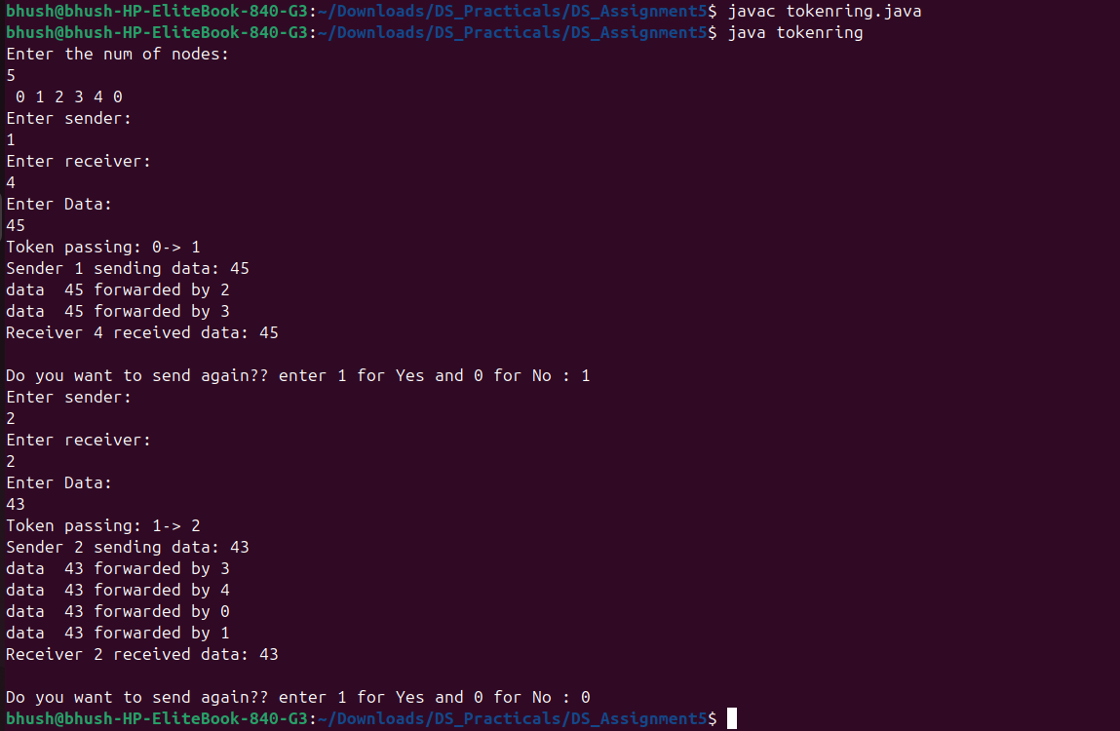
javac tokenring.java java tokenring

Terminal 1 :
javac Bully.java java Bully
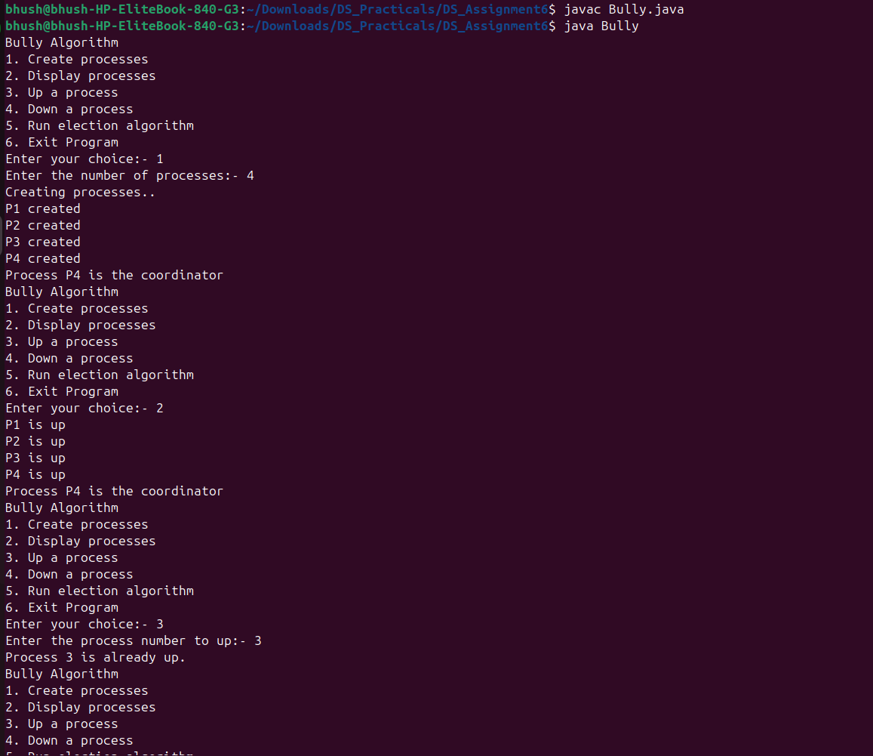

Terminal No : 2
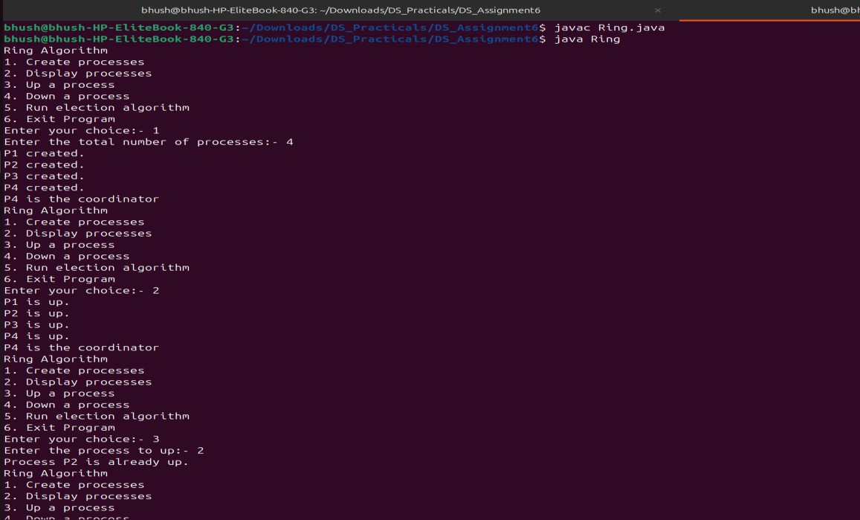
javac Ring.java java Ring

